**Financial Time-Series Anomaly Detection**

**Project Overview:**

Financial markets are complex and dynamic, with stock prices influenced by a multitude of factors such as market trends, economic indicators, and investor behavior. Detecting anomalies in stock price movements is crucial for identifying unusual activities, potential fraud, or market manipulations. This project aims to develop a tool that can analyze financial time-series data and detect anomalies using machine learning techniques. By leveraging historical stock price data, technical indicators, and advanced modeling approaches, this system will help financial analysts and traders gain insights into unusual price movements and make informed decisions.

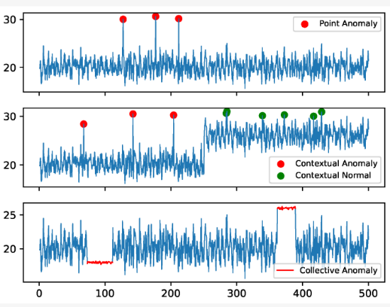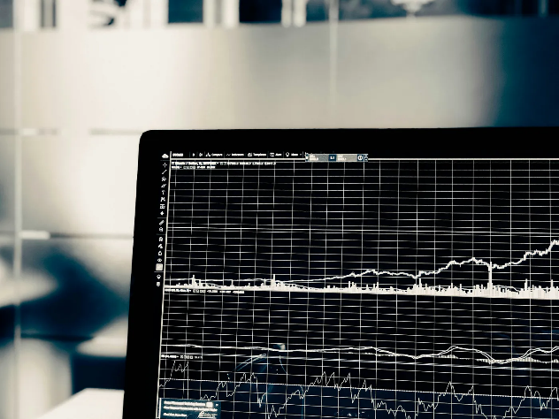

**Project Objectives:**

1. **Data Collection and Preprocessing:**
   * Download historical stock price data from Yahoo Finance for selected companies.
   * Clean and preprocess the dataset by handling missing values, adjusting time formats, and normalizing price movements.
2. **Feature Engineering:**
   * Compute financial indicators such as Simple Moving Average (SMA), Exponential Moving Average (EMA), Relative Strength Index (RSI), and Bollinger Bands.
   * Identify relevant features that enhance anomaly detection capabilities.
3. **Anomaly Detection Using Machine Learning:**
   * Implement unsupervised anomaly detection algorithms such as Isolation Forest and DBSCAN.
   * Analyze detected anomalies and validate their significance in stock price trends.
4. **Time-Series Forecasting for Deviation Detection:**
   * Develop a predictive model using Long Short-Term Memory (LSTM) or Facebook Prophet to forecast stock prices.
   * Compare actual prices with predicted values to identify unusual deviations.
5. **Visualization and Reporting:**
   * Plot stock price trends with detected anomalies highlighted for easy interpretation.
   * Generate reports summarizing detected anomalies and potential market manipulations.

**Dataset:**

Download the data from (finance) using “ yfinance library ”

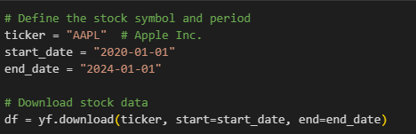 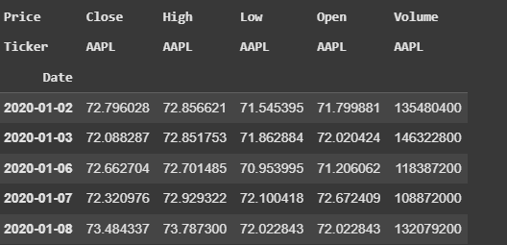

**Libraries**

What libraries that we used in this project actually.

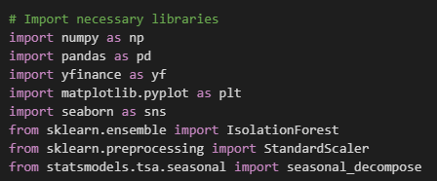

**Models**

For **Financial Time-Series Anomaly Detection**, we use

* **Isolation Forest & DBSCAN** for unsupervised anomaly detection.
* **LSTM & Prophet** for time-series forecasting to identify deviations.
* A **hybrid approach** combining LSTM forecasting with Isolation Forest improves accuracy.

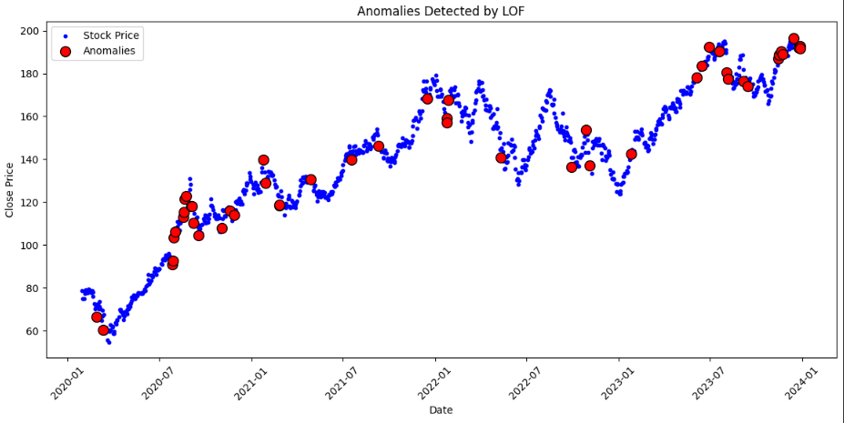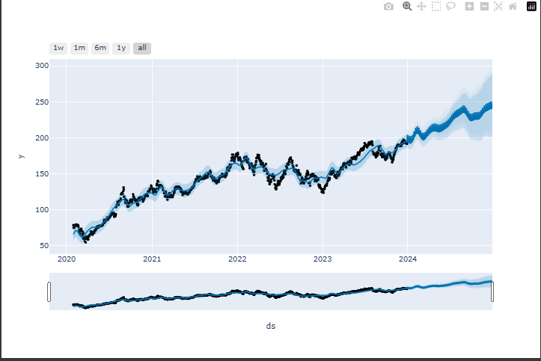

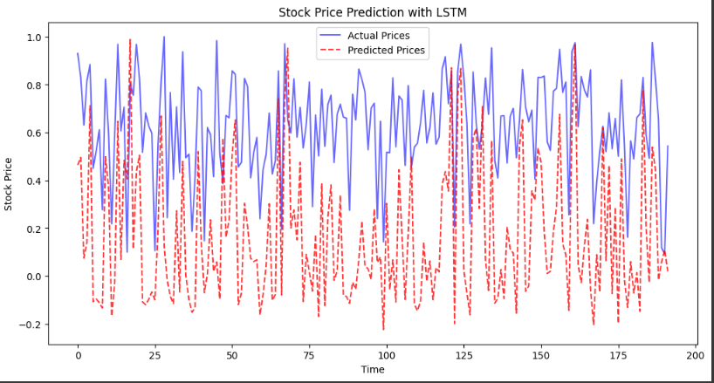

**Environment:**

Google colab

**Google colab link :**

[**https://colab.research.google.com/drive/1D_At03pRbFkXiPHtc-G9D1zWA_Xq1qPa?usp=sharing**](https://colab.research.google.com/drive/1D_At03pRbFkXiPHtc-G9D1zWA_Xq1qPa?usp=sharing)